CHILD SAFEGUARDING AND WELFARE

POLICY & PROCEDURES

July 2022
Contents

Section 1 - Child Protection and Welfare Policy and Procedures Statement: 3
Key Roles & Responsibilities: 5
Section 2 - Code of Behaviour: 8
Code of Behaviour for Children: 8
The Galway Music Residency Code of Behaviour: 8
Child-centred approach: 8
Good Practice: 9
Communications and Social Media: 10
Inappropriate behaviour: 11
Physical Contact: 11
Health and Safety: 11
Photography: 12
Section 3 - Inclusion: 13
Section 4 - Anti-Bullying Policy: 13
Section 5 - Recording & Reporting Procedures: 15
Recording procedures: 15
Dealing with a disclosure: 16
Reporting procedures: 16
Retrospective disclosure: 17
Section 6 - Statement of Confidentiality: 18
Section 7 - Procedures for Recruiting and Selecting Staff: 19
Section 8 - Training, Managing and Supervising Staff: 20
New staff: 20
All staff: 20
Section 9 - Involvement of primary carers: 21
Section 10 - Allegations of Misconduct or Abuse by Staff members 22
Section 11 - Complaints and Comments: 23
Section 12 - Incidents and Accidents 23
Section 13 - Safe Management of Activities 23

Appendix A – Definitions of Abuse 26
Neglect 26
Emotional abuse 26
Physical Abuse: 27
Sexual Abuse 28
Appendix B – Recognising Abuse / Reasonable Grounds for Concern 29
Appendix C – Talking to Parents about Concerns for Child’s Welfare 31
Appendix D – Information for Children 32
Appendix E – Contacting Tusla 33
Appendix F – Contacing An Garda Siochána 35
Appendix G – Declaration Form 36
Appendix H - Standard Form Report Form 37
Appendix I - Photographic/Recording Consent Form: 40
Appendix J - Child Safeguarding Statement: 41

Section 1 - Child Protection and Welfare Policy and Procedures Statement

Galway Music Residency provides a Music Education and Music outreach service to children and young people.

The Galway Music Residency is committed to the provision of a safe, positive, fun and enlightening environment for children participating in all of our events. We undertake to adopt a child-centred approach to all of our activities involving children and we will adhere to the recommendations of the Children First: National Guidelines for the Protection and Welfare of Children.

Our guiding principles
- Our priority to ensure the welfare and safety of every child and young person who takes part in Galway Music Residency Activity is paramount.
- Our guiding principles and procedures to safeguard children and young people reflect national policy and legislation and we will review our guiding principles and child safeguarding procedures at least every two years.
- All children and young people have an equal right to take part in Galway Music Residency Activities in a way that respects them as individuals and encourages them to reach their potential, regardless of their background.
- We are committed to upholding the rights of every child and young person who takes part in a Galway Music Residency activity, including the rights to be kept safe and protected from harm, listened to and heard.
- Our guiding principles apply to everyone in our organisation.
- Workers/volunteers must conduct themselves in a way that reflects the principles of our organisation.

The Galway Music Residency undertakes to implement policy and procedures in relation to:

- Key Roles & Responsibilities;
- Code of Behaviour for all staff;
- Inclusion;
- Anti-Bullying;
- Reporting of suspected or disclosed abuse;
- Confidentiality;
- Recruitment and selecting staff;
- Training, Managing and Supervising staff;
- Involvement of primary carers;
- Allegations of misconduct or abuse against staff;
- Complaints and comments;
- Incidents and accidents;
- Safe management of activities

This document has been compiled with reference to the relevant legislation (Children First Act 2015, National Vetting Bureau (Children and Vulnerable Persons) Act 2012) as well as Children First: National Guidance for the Protection and Welfare of Children Second Edition (2017) and related support documents, as provided by Tusla, the Child and Family Agency.

This policy and procedures document is available to all Galway Music Residency staff and board members as well as primary carers participating in Galway Music Residency activities.

This policy will be reviewed on a 24-month basis. The next review will take place in July 2024.

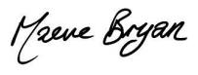
Signed:

Date: July 2022

Key Roles & Responsibilities:
The key individuals responsible for implementation review and reporting in relation to the Galway Music Residency Child Protection Policy and Procedures will be the Designated Person and the Deputy Designated Person.

The Role of the Designated Liaison Person is to:

- Be fully familiar with Galway Music Residency’s responsibilities in relation to the safeguarding of children.
- Have good knowledge of Galway Music Residency’s guiding principles and child safeguarding procedures.
- Ensure that Galway Music Residency’s reporting procedure is followed, so that child protection and welfare concerns are referred promptly to Tusla.
- Receive child protection and welfare concerns from workers and volunteers and consider if reasonable grounds for reporting to Tusla exist.
- Consult informally with a Tusla Duty Social Worker through the Dedicated Contact Point, if necessary.
- Where appropriate, make a formal report of a child protection or welfare concern to Tusla on behalf of Galway Music Residency, using the Tusla Web Portal or the Tusla Child Protection and Welfare Report Form.
- Inform the child’s parents/guardians that a report is to be submitted to Tusla or The Garda Síochána, unless:
- Informing the parents/guardians is likely to endanger the child or young person;
- Informing the parents/guardians may place you as the reporter at risk of harm from the family;
- The family’s knowledge of the report could impair Tusla’s ability to carry out an assessment.
- Record all child protection or welfare concerns, or allegations of child abuse, brought to your attention as well as any action taken in response to these concerns.
- Provide feedback to the referrer, as appropriate.
- Ensure that a secure system is in place to manage and store confidential records.
- Act as a liaison with Tusla and The Garda Síochána, as appropriate.
- Where appropriate, jointly report with a mandated person.
- Support and advise staff about policy and procedures in relation to child protection;
- Support the Deputy Designated Person;
- Keep up to date regarding Child Safeguarding legislation and Tusla guidelines

Designated Liaison Person:
Maeve Bryan (GMR Executive Director)
Contact Details:
The Galway Music Residency, NUI Galway, Riverside Terrapin, Distillery Road, Lower Newcastle, Galway
Tel: 091 586706, maeve@thegalwaymusicresidency.ie

The Role of the Deputy Designated Liaison Person is to:
- Act in the role of the Designated Person when the Designated Person is unavailable;
- Support the Designated Liaison Person;

Deputy Designated Liaison Person:
Orla Henihan (GMR Administrative Assistant)
Contact Details:
The Galway Music Residency, NUI Galway, Riverside Terrapin, Distillery Road, Lower Newcastle, Galway
Tel: 091 586706, orla@thegalwaymusicresidency.ie

The role of the Relevant Person is to

- be the first point of contact in relation to the Child Safeguarding Statement;

Relevant Person:
Maeve Bryan (GMR General Manager)
Contact Details:
The Galway Music Residency, NUI Galway, Riverside Terrapin, Distillery Road, Lower Newcastle, Galway
Tel: 091 586706, maeve@thegalwaymusicresidency.ie

When the Relevant Person is unavailable the role will be carried out by:
Orla Henihan (GMR Administrative Assistant)
Contact Details:
The Galway Music Residency, NUI Galway, Riverside Terrapin, Distillery Road, Lower Newcastle, Galway
Tel: 091 586706, orla@thegalwaymusicresidency.ie

Mandated Person/s:

On the basis of the current definitions Galway Music Residency does not currently employ any staff member who falls under the “mandated person” statutory categories. This policy is written on the basis of Galway Music Residency’s current position of not having any Mandated Person on staff. If Galway Music Residency comes to employ Mandated Persons in the future, or work with professionals within the ‘mandated persons’ category, the Mandated Person would be responsible for fulfilling their obligations under the Children First Act 2015 in parallel to Galway Music Residency Designated Liaison Person. It is important to note that the Designated Liaison Person cannot fulfil the mandatory reporting obligations on behalf of the Mandated Person. Galway Music Residency will maintain a list of the persons (if any) who are Mandated Persons. While Mandated Persons have statutory obligations to report mandated concerns, they can make a report jointly with another person. Therefore a Mandated Person could make a joint report with the Designated Liaison Person. If a concern arises about a child attending Galway Music Residency with a group which includes a Mandated Person(s) (e.g. Teachers, Social Workers, etc.), then Galway Music Residency’s Designated Liaison Person will liaise with the Mandated Person(s) and, if the threshold for making a report is met, would either make a joint report with the Mandated Person(s) or a separate report.

Section 2 - Code of Behaviour
The Code of Behaviour lists the type of behaviours and responsibilities that staff of the Galway Music Residency will adhere to when working with children. The Code concerns all staff members and the administrative responsibilities of the Galway Music Residency.

Code of Behaviour for Children
A Code of Behaviour for the children participating in the Galway Music Residency events should be drawn up at the beginning of the activities for children and young people. The code will:
- be compiled through discussion between the children and the staff member and should involve and include suggestions from the children;
- list the types of behaviour that will support a positive and inclusive environment for the activity
- list the types of behaviour that will not be accepted during the session and the penalty that will be imposed should the children break one of the codes;
- be revisited at the beginning of every subsequent session.
Primary carers are welcome to view the contract.

Use of Technology
- Mobile phones will be switched off during workshops, rehearsals and performances.
- The sharing of images on any social media or networking site is strictly forbidden without the express permission from all parties involved.
- Cameras will not be used to take compromising, inappropriate or explicit pictures or recordings of any other participant or adult. Sharing of any such images on any social media or networking site is strictly forbidden.

The Galway Music Residency’s Code of Behaviour:
The Galway Music Residency Code of Behaviour for staff members is presented under the following categories:
- Child-centred approach
- Good practice
- Communications and Social Media
- Inappropriate behaviour
- Physical contact
- Health & Safety

Child-centred approach
Artist/Facilitator:
- Encourage feedback from the group;
- Treat all children equally and as individuals;
- Listen to and respect children;
- Respect a child’s personal space;
- Involve children in decision-making, where appropriate;
- Offer constructive criticism when needed but provide encouragement, support and praise (regardless of ability);
- Use age-appropriate language (physical and verbal);
- Use age-appropriate teaching aids and materials;
- Have fun and encourage a positive, trusting atmosphere;
- Lead by example;
- Be cognisant of a child’s limitations, for example, due to a medical condition;
- Respect differences of ability, culture, religion, race and sexual orientation.
- Discuss boundaries of behaviour and related sanctions, as appropriate, with children and their primary carers;

Good Practice
Artist/Facilitator:
- Plan your session and be sufficiently prepared, both mentally and physically; think about how you communicate with children;
- Observe appropriate dress and behaviour;
- Be inclusive of all children with special needs;
- Encourage children to report any bullying, concerns or worries;
- Do not take a session on your own. If this is not possible, then it should be in an open environment with the full knowledge and consent of primary carers and the Galway Music Residency;
- Do not spend time alone with children. In an unavoidable situation where you find yourself alone with a child, please contact the primary carer or GMR;
- Do not transport children to or from a session in your car;
- Maintain awareness around language and comments made. If you think that something you said might have caused upset or offence, then try to address it in a sensitive manner;
- Evaluate work practices on a regular basis;
- Report and record any incidents, accidents or concerns in accordance with the Reporting Procedures.
- Any contact with young people via phone, text, email must be done with parental consent.
- Do not let allegations made by a child go unrecorded;
- Do not make or receive private calls/texts while facilitating /supervising an activity.
- Do not contact young people through social networking sites.

Promoters:
- Exercise good communication with the primary carer.

The Galway Music Residency permanent staff:
- Communicate fully with the artists, facilitators, promoters, key workers etc. engaged in GMR programmes;
- Provide appropriate training for staff;
- Update and review policies and procedures regularly.

The Galway Music Residency permanent staff & Artist/Facilitator:
- In the case of a workshop hosted directly by GMR, create and maintain a register containing the following details for each child: name, address, phone number, special requirements, attendance, emergency contact and any other necessary information (e.g. dietary requirements, allergies etc.);
- In the case of a workshop hosted directly by GMR, make primary carers, children, visitors, teachers/group leaders and facilitators aware of the Child Protection Policies & Guidelines;
- In the case of a workshop hosted directly by GMR, keep primary carers informed of any issues that concern their children;
- Have Emergency Procedures in place and make all staff aware of these procedures;
- Ensure appropriate supervision based on adequate ratios according to age, abilities and activities involved.
- If an employee reports a workplace concern in good faith and on reasonable grounds in accordance with the procedures outlined in the legislation, it will be treated as a ‘protected disclosure’ under the Protected Disclosures Act 2014.
- Report concerns about other workers’ behaviour

Communications and Social Media
Galway Music Residency is committed to ensuring that all communications with the young participants in our activities are appropriate and are carried out through appropriate channels.

Galway Music Residency acknowledges that staff and young people may have appropriate, pre-existing, professional, personal or student/teacher relationships and we do not interfere with these.

The initiation of new professional or tutor-student relationships in the context of Galway Music Residency activities should be communicated to the course manager and Designated Liaison Person. In the case of under 18s, permission for ongoing contact must be received from parents / guardians.

Keeping in mind those qualifications:
- Staff members should not contact young people for reasons other than those directly connected to activities in which they are participating;
- Staff members should only use official / company phones, communications methods or accounts to communicate with young people on our activities;
- Staff members should not give out their personal phone numbers, email addresses or other contact details to any young person;
- Telephone / SMS contact with participants should only be via official Galway Music Residency phones and be restricted to necessary communications;
- In the case of a safety concern or emergency, personal communications devices may be used to communicate with participants but the Course Manager / Designated Liaison Person should be informed as soon as possible thereafter. Participants’ contact details should then be deleted from the personal device.
- Staff members should not provide participants’ contact details to other participants or third parties without express permission. In the case of under 18s, this requires the permission of parents / guardians;
- Please be aware that adding participants to WhatsApp groups and similar services can expose their contact details. Consider using a “broadcast” function instead of such a group.
- Staff should not connect to or interact with participants via personal social media channels;
- Friend requests should be politely declined explaining to the young person, if the opportunity arises, that this is the policy of Galway Music Residency.
- No defamatory, insulting or provocative material can be posted on our online platforms.
- Staff are advised to check privacy settings on their personal social media channels and monitor carefully for any changes that social networking sites may make to their settings in relation to client privacy

Inappropriate behaviour
- Do not use or allow offensive or sexually suggestive physical and/or verbal language;
- Do not single out a particular child for favouritism, criticism, ridicule or unnecessary focus or attention;
- Do not allow/engage in inappropriate touching of any form;
- Do not hit or physically chastise children;
- Do not socialise inappropriately with children, i.e. outside of structured organisational activities.

Physical Contact
- Always seek the child’s consent in relation to physical contact (except in an emergency or a dangerous situation);
- Do not engage in physical horseplay or inappropriate touch;
- Check with children about their level of comfort when engaged in touch exercises.
- Do not do things of a personal nature that children can do for themselves.

Health and Safety
Promoter/ Artist/Facilitator:
- Provide a safe environment;
- Never leave children unattended or unsupervised;
- Manage any dangerous materials;
- Follow all incident, accident and other reporting procedures.

Photography
- The Galway Music Residency endorses the Arts Council’s Guidelines for taking and using images of children and young people in the arts sector
- GMR is committed to following this code of practice where appropriate.
- GMR is also committed to advocating that its Partner Promoters follow this code of practice where appropriate.
- Where images/recordings are undertaken by GMR, they will be done so on the basis of ‘Informed Consent’.
- A sample consent form (related to photography and code of behaviour) is included in Appendix I.

Section 3 – Inclusion

Galway Music Residency’s ethos is to ensure that everyone has the opportunity to engage with music. We aim for inclusive experiences for all in relation to the work that we do. Galway Music Residency is currently working on developing a formal organisation-wide policy around equality, diversity and inclusion.

Section 4 – Anti-Bullying Policy

Bullying has no place in Galway Music Residency. Staff and vounteers should promote a positive anti-bullying ethos during activities and raise awareness amongst other staff, volunteers and participants that bullying should not be tolerated. By emphasising the Galway Music Residency’s codes of conduct, staff and volunteers should create an environment in which all people are valued as individuals with rights and are encouraged and affirmed.

What is Bullying?

Bullying can be defined as repeated aggression be it verbal, psychological or physical conducted by an individual or group against others. It is behaviour that is intentionally aggravating and intimidating. It includes behaviours such as teasing, taunting, threatening, hitting and extortion by one or more people against a target or targets. It can also include ignoring an individual and purposely making them feel marginalised and excluded from the group.

Anyone can be affected by bullying, be they staff, management, volunteers, or young people. We recognise that any of these individuals can also be a perpetrator of bullying.

The Results of Bullying

The effects of bullying can last for some time and can significantly affect an individual’s wellbeing, causing poor social development and depression.
The outcomes of bullying can include:
• Physical injury, headaches, stomach aches;
• Stress symptoms such as sleep or eating disorders, anxiety and panic attacks;
• Loss of confidence and self-esteem;
• Reluctance to take part in activities;
• Lowered academic achievement;
• Exclusion and isolation;
• Consideration of suicide.

Dealing with a Disclosure of Bullying

It is important for staff and volunteers to take a proactive role in investigating whether bullying is occurring because many young people will not tell. However, a young person may confide in anyone so everyone should be aware of how to handle such a confidence.

What can you do if a child / young person tells you they are being bullied?

- Listen calmly and accept what is said. If possible, there should be two staff present (but this should be determined by the needs of the young person). If not leave the door open so passers-by can see the staff member but not the young person making the disclosure.
- Take notes following the conversation and keep these on file as this forms the basis of the bullying report. Notes should include nature of incident, date, time, location, names of those involved, witnesses, relevant history and staff member’s response.
- Reassure the young person that help is available, action will be taken, that they were right to tell, it is not his or her fault and it could happen to anyone.
- Negotiate confidentiality and be clear you’ll only tell people who need to know.
- Ensure the young person’s safety. Safety is paramount and this can be maintained through appropriate supervision. Liaise with the young person’s guardian in relation to a solution and possible actions.
- Tell the young person that you’ll keep them informed as to how you intend to proceed.
- Make an intervention and ensure that all your actions will be guided by the needs of the young person. The following is a list of possible actions:
  - Inform your line manager of your concerns;
  - Decide who to consult with: guardians of the alleged bully and alleged victim;
  - Decide who to interview: witnesses, alleged bullies;
  - Find out: what, where, when, who, how, why? Act in a non-confrontational manner.
- Resolve the problem: Make bullying the responsibility of all young people in the group. Alternatively, approach the victim and the bully (explain why the bully’s behaviour is wrong, how it makes the victim feel and request an apology); parents / legal guardians and bully (if sanctions linked to the behaviour are to be employed, request the parents / legal guardians to reinforce these).
- Refer on in difficult cases: if it remains unresolved, a report should be fully written up and referred on to the Board of Directors. The Galway Music Residency Incident Form can be used for this. The report should include any of the notes taken at the time.
- Make a record of facts rather than opinions. Include details from the bullying report (i.e. nature of incident, date, time, location, names of those involved, witnesses, relevant history and staff member’s response), details recounted by others involved, any agreements made, an account of action taken and suggestions for follow up and monitoring. Use the official Galway Music Residency Incident Report Form for the bullying report. Reassure the young people involved that this report will be kept in confidence and its contents will only be revealed to those who need to know. This form must be returned to the Galway Music Residency office for safe-keeping and to be used in any subsequent actions or follow-up to the incident.

Staff may find pp. 105-109 of the Tusla Child Protection Handbook 2 a useful reference in this regard:
https://www.tusla.ie/uploads/content/Tusla_Child_Protection_Handbook2.pdf

Section 5 – Procedures for Responding to, Recording & Reporting Child Safety Concerns
In order that staff may appropriately identify, express, record and report concerns about children, it is imperative that the following procedures are followed closely.

Identifying Reasonable Grounds for Concern

There are many reasons a staff member may be concerned about the welfare or protection of a child or young person. Appendices A and B are essential references and provide guidance on definitions of abuse, recognising abuse, and identifying reasonable grounds for concern.

Recording procedures
In the circumstances where staff members feel that there are reasonable grounds for concern, the reporting procedures below should be followed carefully.

Staff should record the following information in relation to children:
- Suspicions
- Concerns
- Worrying observations
- Behavioural changes
- Actions and outcomes

Records should be factual, easy to read, dated and signed. Written records of this nature should be submitted to the Designated Liaison Person and kept in a locked cabinet at the Galway Music Residency’s offices. These records are not to be viewed by anyone not directly connected with the report.

Dealing with a disclosure
- Stay calm and listen to the child, allow the child enough time to say what they need to say;
- Accept what the child says;
- Do not use leading questions or prompt details. If clarification is required, try to use language that is similar to that used by the child;
- Reassure the child but do not promise to keep anything secret;
- Do not make the child repeat the details unnecessarily;
- Explain to the child what will happen next (explanation should be age-appropriate);
- Remain supportive to the child.

Reporting procedures
Reports of abuse or suspected abuse will be made to the relevant authorities. In the event of a concern or disclosure of abuse, staff should follow these reporting procedures:
- In the event of a disclosure:
  - Record all details, including date, time, and people involved in the disclosure and the facts (for example, in the Incident/Accident Book); Information recorded should be factual;
  - Try to use exact quotations from the child’s testimony and do not use your own language in the record;
  - If necessary, draw a discrete diagram to illustrate any injuries that may have been reported in the course of the disclosure.
- Inform the Designated Person (or the Deputy Designated Person, if unavailable);
- If the Designated Person and Deputy Designated Person are not available, contact the local Duty Social Worker in Tusla directly. Appendix E contains contact details for the appropriate Duty Social Worker in Tusla.;
- The Designated Person will contact the Tusla Duty Social Worker for an informal consultation prior to making a report; any concern should then be reported to Tusla without delay.
- Any concern about a potential risk to children posed by a specific person, even if the children are unidentifiable, should also be reported to Tusla
- Failure to report and failure to take steps with regard to child protection and abuse is in breach of the “Reckless Endangerment of Children” Section 176, Criminal Justice Act, 2006
- Withholding information relating to the commission of a serious offence, including a sexual offence, against a person who is under the age of 18 years or an otherwise vulnerable person is a criminal offence under the Criminal Justice (Withholding of Information on Offences against Children and Vulnerable Persons) Act 2012, Sections 2 and 3.
- In the case where the Designated Liaison Person decides not to report concerns to Tusla, the individual employee or volunteer who raised the concern will be given a clear written statement of the reasons why the organisation is not taking such action
- The Protection for Persons Reporting Child Abuse Act 1998 makes provisions for the protection from civil liability of persons who have communicate child abuse ‘reasonably and in good faith’ to designated officers of Tusla or to any member of An Garda Síochána
- If there are reasonable grounds for concern, the Designated Person will contact the Duty Social Worker using the standard reporting form available from Tusla. (Reports to the Duty Social Worker can be made verbally, initially, and then followed by the standard reporting form. Reports should be made to Tusla without delay);
- The most appropriate person should discuss the concern or consult with primary carers. Parents, carers or responsible adults should be made aware of a report to Tusla unless it is likely to put the child at further risk; Appendix C outlines guidance on Talking to parents/guardians about child protection or welfare concerns
- Information will be shared on a strictly ‘need to know’ basis;
- In case of emergencies outside of Tusla’s service hours, contact the Gardaí. In situations that threaten the immediate safety of a child, it may be necessary to contact the Gardaí;
- In the case of a staff member reporting a concern, they are invited to contact the Duty Social Worker with Tusla to discuss their concern. If the Duty Social Worker deems the concern to be a reasonable concern, then the above procedures should be followed;
- If concerns about a child are reported anonymously, they will be followed up fully in accordance with Tusla standard procedures. If the report has been made through a third party, the person mediating should be requested to facilitate contact between the original person who reported the concern and Tusla
- The reporting procedures will be known and accessible to all staff. Throughout the process, the person who expresses the concern should be involved and kept informed, where appropriate. When a report has been made to the Designated Person, all actions and outcomes should be noted.
- Staff members reporting abuse are entitled to request written acknowledgement from the body with whom the complaint has been lodged (e.g. Designated Person or Duty Social Worker). Likewise, the Designated Person is entitled to request written acknowledgement from the Duty Social Worker or the Gardaí acknowledging the receipt of the report.
- If there is concern that a child is missing, contact the Designated Person without delay.

Retrospective Disclosure
(In the case of an adult disclosing abuse that took place during their childhood)

- If any risk is deemed to exist to a child who may be in contact with an alleged abuser, a report should of the allegation should be made to Tusla without delay.
- The HSE National Counselling Service is in place to listen to, value and understand those who have been abused in childhood. The service is a professional, confidential counselling and psychotherapy service and is available free of charge in all regions of the country (see www.hse-ncs.ie/en). The service can be accessed either through healthcare professionals or by way of self-referral (Freephone 1800 477477).

The Board of Management of Galway Music Residency agree that the advice of the Duty Social worker in relation to reporting will supersede any other considerations.

Section 6 - Confidentiality Statement

Galway Music Residency is committed to ensuring all people's rights to confidentiality. All staff and volunteers should respect the privacy of other people and not engage in harmful gossip or disclosure.

- Personal data will be kept in line with GDPR guidelines
- Where photography/film recordings are undertaken by GMR, they will be done so on the basis of ‘Informed Consent’. (however, we cannot guarantee that cameras/videos will not be used by other parties during public performances);
- Images of children will not be published without the informed consent of the parent/carer

In relation to child protection and welfare:
- We will treat information about young people appropriately and respect their privacy. However, confidentiality cannot be promised:
- In the case of a child welfare / protection issue
- If there is a serious concern that there may be a threat to the health, safety or life of any person;
- In the context of criminal behaviour and disclosures required by legal process.
- We will cooperate with Tusla in the appropriate sharing of our records where a child welfare or protection issue arises
- Information will only be forwarded on a 'need to know' basis in order to safeguard a child or young person;
- Primary carers and young people will be informed if personal information is being shared and / or a report is being made to Tusla unless doing so could put the child or young person at further risk (see Appendix C);
- Procedures for the recording and storing of information will be in line with our confidentiality and data protection policies;
- The Confidential Report File will be kept in a locked cabinet in the Galway Music Residency office. Any reports completed during activities will be kept safely by the Designated or Deputy Designated Liaison Person until they can be added to the file.

Section 7 - Procedures for Recruiting and Selecting Staff
The Galway Music Residency recognises the importance of selecting appropriate staff to work with children. The Galway Music Residency will ensure that staff are carefully selected, trained and supervised to provide a safe environment for all children by observing the following principles:
- Roles and responsibilities will be clearly defined for every job (paid or voluntary);
- Posts will be advertised for prospective positions as widely as possible
- Applicants will be provided with information about GMR and its activities
- Candidates will be required to complete a written application.
- Candidates will be required to provide contact details for at least two recent, relevant, independent referees;
- Staff will be selected through a process involving a panel of at least two representatives;
- GMR will endeavour to select the most suitably qualified personnel;
- GMR will not employ someone deemed to be a risk to the safety and welfare of children. Some of the exclusions include:
  - Any child-related convictions;
  - Insufficient documentary evidence of identification;
  - Concealing information regarding suitability to work with children;
- Every employee will undergo a probationary period of six months;
- Identification will be made available which includes the name and address together with a signature or photograph. All staff working with children on a continuous basis will undergo Garda Vetting as part of the recruitment process. For once-off activities, where there is minimal potential for a relationship of trust to be established between the participants and facilitator, the local coordinator will be responsible for ensuring a suitable adult supervisor is present with the facilitator and participant group at all times during the Learning and Participation activity. Garda Vetting of the facilitator will not be carried out in this instance.

Section 8 – Training, Managing and Supervising Staff
The Galway Music Residency recognises that responsible management and supervision of staff working directly with children will lead to the effective execution of the Child Protection Policy and Procedures. The Galway Music Residency undertakes to ensure that:

New staff will
- Complete the Tusla Children First E-Learning Programme can be accessed on the Tusla website at https://www.tusla.ie/
- Be made aware of the organisation’s code of behaviour, child protection procedures, and the identity and roles of the Designated Liaison Person and the Deputy Designated Liaison Person;
- undergo a probationary period of six months.

All staff will
- Receive an adequate level of supervision and review of their work practices;
- Read the Child Safeguarding Statement and Child Protection Policy and Procedures documents
- Staff working directly with children (or vulnerable adults) will complete the Declaration Form.

The Designated Liaison Person and Deputy Designated Liaison Person will
- Be provided with training appropriate to these specific roles. This training will be sourced through the Irish Association of Youth Orchestras (of which Galway Music Residency is a member) and their affiliation with the National Youth Council of Ireland

Records of any staff training taken will be maintained in the Galway Music Residency Child Safeguarding File.

Section 9 - Involvement of primary carers
The Galway Music Residency respects the role of primary carers and to this end, it is important that we involve those in that role in the implementation of these policies and procedures. In order to fulfil that objective, the Galway Music Residency will:

- Make our Child Safeguarding Statement publicly available on our website
- Advise primary carers of the availability of the child protection policy and procedures;
- Inform primary carers and schools of all activities and potential activities;
- Issue contact/consent forms as necessary;
- Comply with health and safety practices;
- Operate child-centred policies in accordance with best practice;
- Ensure as far as possible that the activities are age-appropriate;
- Encourage and facilitate the involvement of parent(s), carer(s) or responsible adults, where appropriate.

If staff of the Galway Music Residency experience concerns about the welfare of the child, the staff will:
- Respond to the needs of the child;
- Keep primary carers fully informed of all procedures and necessary information, unless to do so would place the child at further risk;
- Follow the recording and reporting procedures outlined in this document including reporting to the Duty Social Worker and, in the case of an emergency, the Gardaí;
- In the event of a complaint against a member of staff, we will immediately ensure the safety of the child and inform primary carers where appropriate.

The Galway Music Residency is committed to putting the interests of the child first. To that end, the staff will:
- Contact Tusla and Gardaí where there is a child protection welfare concern;
- Encourage primary carers to work in partnership with us under the guidelines set out by our organisations to ensure the safety of their children;
- Allocate a contact person for consultation with primary carers in the case of any concern over a child’s welfare.

Section 10 - Allegations of Misconduct or Abuse by Staff members
In the event that allegations are made against a Galway Music Residency staff member, the protection of the child will be the paramount consideration. Two separate procedures will be followed: one in respect of the child and one in respect of the staff member against whom the allegation has been made. Two separate key authorities will deal with each separate procedure. The Galway Music Residency will take protective measures appropriate to the level of risk while not unreasonably penalising the worker – unless necessary to protect the child. Protective measures might include:
- Increased supervision
- Assignment to different duties
- Suspension

In respect of the child:
- The Designated Liaison Person will deal with issues relating to the child.
- If allegations are made against the Designated Liaison Person, the Deputy Designated Liaison Person should be contacted and vice versa;
- The first priority will be to ensure that no child is exposed to unnecessary risk;
- The reporting procedures outlined in Section 5 of this document should be followed. Both the primary carers and the child should be informed of actions planned and taken. All communication with the child should occur in an age-appropriate manner.

In respect of the staff member:
- The INSERT NAME/ROLE HERE will deal with issues relating to the staff member.
- If allegations are made against the INSERT NAME/ROLE HERE, the chairperson of the organisation should be contacted as soon as possible;
- The staff member will be informed as soon as possible of the nature of the allegation;
- The staff member will be given the opportunity to respond;
- Any action following an allegation of abuse against an employee should be taken in consultation with the Tusla and Gardaí;
- After consultation, the chairperson should advise the person accused and agreed procedures would be followed.

Section 11 - Complaints and Comments
If primary carers and other key stakeholders wish to make a complaint or comment about some aspect of the Galway Music Residency projects involving children, they can do so in writing by email or post. Complaints and comments should be addressed to the to the Designated Liaison Person.

Complaints, comments or feedback will be:
- the responsibility of the Designated Liaison Person;
- responded to within 2 weeks;
- be recorded and responded to appropriately.

If the complainant is not happy with the response provided they may address their concerns to the Chairperson of the board of directors Galway Music Residency.

Section 12 - Incidents and Accidents
In situations where the Galway Music Residency is operating projects without the assistance of a host partner organisation, all incidents and accidents that occur should be recorded in the ‘Accident Book’. The material recorded in the ‘Accident Book’ may be sensitive and will be kept in a locked compartment by the Designated Person. The book will be available to staff members to add entries and must be returned to the Designated Person.

In order to effectively manage instances of incidents and accidents, the Galway Music Residency must:
- Maintain an up-to-date register of the contact details of all children involved in the organisation;
- Cross-reference children’s contact details between the accident book and;
- Where necessary, ensure that external organisations with whom we have dealings must provide proof that the have public liability insurance.
- Have first-aid boxes available and regularly stocked
- Have the location of the first-aid box(es) known to staff
- Advise children of the risks of dangerous material;
- Record details of risky equipment used and take steps to minimise risk

Section 13 - Safe Management of Activities:

Galway Music Residency is committed to reducing the likelihood of harm through ensuring appropriate procedures are in place regarding how activities are organised and run.

The following will be in place for all activities:

- A registration system for each child/young person taking part
- A record for each child participant that includes address, and family contact details
- A record for each child participant in relation to medical details as appropriate
- Consent forms in relation to photography and filming will be distributed to all parents/guardians when required
- An attendance sheet will be filled at all activities
- An incident report form will be available to staff at all activity locations
- A risk assessment will be carried out in relation to Child Safeguarding, and any identified risks will be mitigated against
- Galway Music Residency Child Safeguarding Policies and Procedures will be adhered to

In relation to Health and Safety the following will be in place for all activities:
- A risk assessment will be carried out in relation to Health and Safety, and any identified risks will be mitigated against
- Galway Music Residency will ensure
- that any buildings used are safe and meet required standards
- sufficient heating and ventilation
- toilets and washing facilities are to standard and meet accessibility requirements of participants
- fire precautions are in place
- there is access to a phone
- insurance cover is adequate
- a first aid kit is on site
- an incident report is completed for all physical accidents
- parents/guardians will be notified promptly in the case of an accident involving their child

Safe supervision of Children

- A schedule of supervision will be in place for all workers and volunteers
- Children will not be left unattended
- Workers and volunteers will be informed of the schedule of activities and will know where the children are and what they are doing
- Online activities will follow the Code of Behaviour outlined above
- Dangerous behaviour is never allowed

One-to-One Practice

Where one-to-one working with children and young people is planned
- Worker adheres to Galway Music Residency’s Code of Behaviour
- Open-door practice applies
- An agreement is in place and signed between Galway Music Residency and the Parent/Guardian of the child participant

Appendix A

Definitions of Abuse:
There are four main categories of abuse outlined in Children First: National Guidelines for the Protection and Welfare of Children. They are:
- Neglect
- Emotional abuse
- Physical abuse
- Sexual abuse

The following is a synopsis of the information contained in the Children First: National Guidelines for the Protection and Welfare of Children, 2017, Department of Children and Youth Affairs

Neglect
‘Neglect is defined as ‘to deprive a child of adequate food, warmth, clothing, hygiene, supervision, safety or medical care’.

The following are features of child neglect:
- Children being left alone without adequate care and supervision
- Malnourishment, lacking food, unsuitable food or erratic feeding
- Non-organic failure to thrive, i.e. a child not gaining weight due not only to malnutrition but also emotional deprivation
- Failure to provide adequate care for the child’s medical and developmental needs, including intellectual stimulation
- Inadequate living conditions – unhygienic conditions, environmental issues, including lack of adequate heating and furniture
- Lack of adequate clothing
- Inattention to basic hygiene
- Lack of protection and exposure to danger, including moral danger, or lack of supervision appropriate to the child’s age
- Persistent failure to attend school Abandonment or desertion

The threshold of harm, at which mandated persons must report to Tusla under the Children First Act 2015, is reached when you know, believe or have reasonable grounds to suspect that a child’s needs have been neglected, are being neglected, or are at risk of being neglected to the point where the child’s health, development or welfare have been or are being seriously affected, or are likely to be seriously affected..’

Emotional abuse/ill-treatment
Emotional abuse is the systematic emotional or psychological ill-treatment of a child as part of the overall relationship between a caregiver and a child. Emotional abuse usually relates to the relationship between a carer and a child rather than a specific incident or incidents. Emotional abuse can manifest in the child’s behaviour or physical functioning. Examples of these include insecure attachment, unhappiness, low self-esteem, educational and developmental underachievement and uncooperative or hostile behaviour.

Emotional abuse may be seen in some of the following ways:
- Rejection
- Lack of comfort and love
- Lack of attachment
- Lack of proper stimulation (e.g. fun and play)
- Lack of continuity of care (e.g. frequent moves, particularly unplanned)
- Continuous lack of praise and encouragement
- Persistent criticism, sarcasm, hostility or blaming of the child
- Bullying
- Conditional parenting in which care or affection of a child depends on his or her behaviours or actions
- Extreme overprotectiveness
- Inappropriate non-physical punishment (e.g. locking child in bedroom)
- Ongoing family conflicts and family violence
- Seriously inappropriate expectations of a child relative to his/her age and stage of development

‘The threshold of harm, at which mandated persons must report to Tusla under the Children First Act 2015, is reached when you know, believe or have reasonable grounds to suspect that a child has been, is being, or is at risk of being ill-treated to the point where the child’s health, development or welfare have been or are being seriously affected, or are likely to be seriously affected.’

Physical Abuse
Physical abuse is when someone deliberately hurts a child physically or puts them at risk of being physically hurt. It may occur as a single incident or as a pattern of incidents. A reasonable concern exists where the child’s health and/ or development is, may be, or has been damaged as a result of suspected physical abuse.

Physical abuse can include the following:
- Physical punishment
- Beating, slapping, hitting or kicking
- Pushing, shaking or throwing
- Pinching, biting, choking or hair-pulling
- Use of excessive force in handling
- Deliberate poisoning
- Suffocation
- Fabricated/induced illness
- Female genital mutilation

‘The threshold of harm, at which mandated persons must report to Tusla under the Children First Act 2015, is reached when you know, believe or have reasonable grounds to suspect that a child has been, is being, or is at risk of being assaulted and that as a result the child’s health, development or welfare have been or are being seriously affected, or are likely to be seriously affected.’

Sexual Abuse
Sexual abuse occurs when a child is used by another person for his or her gratification or arousal, or for that of others.

Examples of child sexual abuse include the following:

Any sexual act intentionally performed in the presence of a child

An invitation to sexual touching or intentional touching or molesting of a child’s body whether by a person or object for the purpose of sexual arousal or gratification

Masturbation in the presence of a child or the involvement of a child in an act of masturbation

Sexual intercourse with a child, whether oral, vaginal or anal

Sexual exploitation of a child, which includes:

Inviting, inducing or coercing a child to engage in prostitution or the production of child pornography [for example, exhibition, modelling or posing for the purpose of sexual arousal, gratification or sexual act, including its recording (on film, videotape or other media) or the manipulation, for those purposes, of an image by computer or other means]

Inviting, coercing or inducing a child to participate in, or to observe, any sexual, indecent or obscene act

Showing sexually explicit material to children, which is often a feature of the ‘grooming’ process by perpetrators of abuse

Exposing a child to inappropriate or abusive material through information and communication technology

Consensual sexual activity involving an adult and an underage person

As all sexual abuse falls within the category of seriously affecting a child’s health, welfare or development, you must submit all concerns about sexual abuse as a mandated report to Tusla. There is one exception, which deals with certain consensual sexual activity between teenagers (see pp.23-24 Children First National Guidance for the Protection and Welfare of Children, 2017, Department of Children and Youth Affairs https://www.tusla.ie/uploads/content/Children_First_National_Guidance_2017.pdf)

Appendix B

Recognising child neglect or abuse

Child neglect or abuse can often be difficult to identify and may present in many forms. A list of indicators of child abuse is contained in Appendix A. No one indicator should be seen as conclusive in itself of abuse. It may indicate conditions other than child abuse. All signs and symptoms must be examined in the context of the child’s situation and family circumstances.

Guidelines for recognition

The ability to recognise child abuse can depend as much on a person’s willingness to accept the possibility of its existence as it does on their knowledge and information. There are commonly three stages in the identification of child neglect or abuse:
(i) considering the possibility;
(ii) looking out for signs of neglect or abuse;
(iii) recording of information.

Reasonable grounds for concern

- Evidence, for example an injury or behaviour, that is consistent with abuse and is unlikely to have been caused in any other way;
- Any concern about possible sexual abuse;
- Consistent signs that a child is suffering from emotional or physical neglect;
- A child saying or indicating by other means that he or she has been abused;
- Admission or indication by an adult or a child of an alleged abuse they committed;
- An account from a person who saw a child being abused.

Wherever appropriate, any issues should be checked with the parents/guardians when considering whether a concern exists, unless doing so may further endanger the child or the person considering making the report. See Appendix C for further guidance in this regard.

Circumstances that may make children more vulnerable to harm

Staff members should also keep in mind circumstances that may make children more vulnerable to harm. Factors might include:
- a parent or a carer
- a child
- the community
- the environment
- poor motivation or willingness of parents or guardians to engage
More guidance and detail in relation to potential circumstances that may make children more vulnerable to harm can be found in the following:
Children First National Guidance for the Protection and Welfare of Children, 2017, Department of Children and Youth Affairs pp.11-12: https://www.tusla.ie/uploads/content/Children_First_National_Guidance_2017.pdf
“Tusla Child Protection and Welfare Practice Handbook 2”: https://www.tusla.ie/uploads/content/Tusla_Child_Protection_Handbook2.pdf
Useful Reference for further details regarding the signs and symptoms of child abuse: Children First: National Guidance for the Protection and Welfare of Children, 2017, Department of Children and Youth Affairs, pp.7-13, Chapter 2, Types of Child Abuse and How They May Be Recognised https://www.tusla.ie/uploads/content/Children_First_National_Guidance_2017.pdf

Remember you must refer – You should not investigate.

Appendix C

Talking to Parents about Concerns for their Child’s Welfare

Galway Music Residency endeavours to ensure that all parents and guardians of children taking part in our activities are made aware of our guiding principles, procedures and duties to safeguard children. Our Child Safeguarding Statement is available on our website and our Child Safeguarding Policy is available on request.

- Be straightforward and clearly explain the nature of the concern or issue, e.g. by using facts and records of observations made.
- Think about the time and place to have the conversation. Find a time when parents/guardians are not in a hurry.
- Find a place that is quiet and allows privacy.
- Consider arranging to meet parents/guardians.
- Consider with the Designated Liaison Person who is best placed to have the conversation with the parents/guardians.
- Use a calm and gentle tone, consider the language used.
- Start with positive comments and observations about the child/young person. Ensure that the parents/guardians know that you care about the welfare of their child and recognise their strengths.
- Refer to how the situation may be affecting the child/young person.
- Start with positive comments and observations about the parents/guardians. Most parents/guardians are trying to do their best for their children and will appreciate your acknowledgement of how challenging parenting can be at times.
- Give the parents/ guardians an opportunity to talk; ask them for an explanation and acknowledge their feelings.
- Take the approach that you are working together to address any issues in the best interests of the child/young person.
- Don’t blame, don’t get defensive and don’t take things personally.
- Ensure that you are supportive but also address the issue.
- Refer to your guiding principles and child safeguarding procedures for support.
- Offer possible solutions, where appropriate.
- Advise parents/guardians how you plan to follow up and keep them informed and involved, where appropriate.

Where it is not possible to contact the parents/guardians to discuss a concern you may need to discuss the concern with the DLP or Tusla duty social worker through the Dedicated Contact Point Remember if a report needs to be made to Tusla, do not delay. It is best practice that parents/guardians are informed if a report is to be made to Tusla, unless doing so might further endanger the child, impair Tusla’s ability to carry out an assessment or put the reporter at risk of harm (Children First: National Guidance for the Protection and Welfare of Children).
Appendix D

Information for Children in relation to our Guiding Principles relating to Child Safeguarding

Galway Music Residency and our work with Children and Young People

- All children and young people have an equal right to take part in Galway Music Residency Activities in a way that respects you as individuals and encourages you to reach your potential, regardless of your background.

- Children and young people have the right to be listened to and heard, you also have the right to be protected from harm. We are committed to upholding the rights of every child and young person who takes part in a Galway Music Residency activity, including the rights to be kept safe and protected from harm, listened to and heard.

- Our priority to ensure the welfare and safety of every child and young person who takes part in Galway Music Residency Activity is paramount.

- Our guiding principles and procedures to safeguard children and young people reflect national policy and legislation and we will review our guiding principles and child safeguarding procedures at least every two years.

- Workers/volunteers must behave in a way that reflects the principles of our organisation.

- Our guiding principles apply to everyone in our organisation.

If you would like to talk to use about any of the above, or if you have any questions, or feedback (positive or negative) about our work the person to talk to or write to is:

Designated Liaison Person:
Maeve Bryan (Executive Director, Galway Music Residency)
Contact Details:
The Galway Music Residency, NUI Galway, Riverside Terrapin, Distillery Road, Lower Newcastle, Galway
Tel: 091 586706, maeve@thegalwaymusicresidency.ie

Appendix E

Tusla Duty Social Work Contact List by County
An up-to-date list of contacts can be found here:
http://www.tusla.ie/services/child-protection-welfare/contact-a-social-worker/
Galway Dedicated Contact Points
Child and Family Agency, 25 Newscastle Road, Galway - 091 546235
OUT OF HOURS ANY QUERY OR CONCERN RELATING TO CHILDREN SHOULD BE REPORTED TO AN GARDA SIOCHANA
Further reading/reference
- Children First: National Guidance for the Protection and Welfare of Children Department of Health and Children Second Edition (DCYA, 2017)
- Our Duty to Care – The principles of good practice for the protection of children and young people (Department of Health and Children 2002)
- Child Protection Guidelines National Youth Federation 2004
- Code of Ethics Good Practice for Children’s Sport Irish Sports Council 2000
- Code of Good Practice: Child Protection for the Youth Work Sector Department of Education and Science 2003
- Child Protection and Welfare Practice Handbook (HSE, 2011)
- Interim Guide for the Development of Child Protection and Welfare Policy, Procedures and Practices (Tusla, 2014)
- Guidelines for taking and using images of children and young people in the arts sector (The Arts Council, 2009)
- Sole practitioner code of practice for working with children and young people (The Arts Council, 2009)
- Guidelines for the protection and welfare of children and young people in the arts sector (The Arts Council, 2006)
Legislation relating to child protection and welfare:
- Child and Family Agency Act 2013
- Child Care Act 1991
- Children Act 2001
- Children First Act 2015
- Criminal justice (Withholding of Information on Offences against Children and Vulnerable Persons) Act 2012
- Criminal Justice Act 2006, Section 176: Reckless Endangerment of Children
- Data Protection Acts 1988 and 2003
- Domestic Violence Act 1996
- Education (Welfare) Act 2000
- Education Act 1998
- Freedom of Information Act 2014
- National Vetting Bureau (Children and Vulnerable Persons) Acts 2012 to 2016
- Non-Fatal Offences against the Person Act 1997
- Protected Disclosures Act 2014
- Protections for Persons Reporting Child Abuse Act 1998
Copies of all legislation can be accessed at www.irishstatutebook.ie.

Appendix F

Contacting An Garda Síochána

An Garda Síochána can be contacted by the following means:

EMERGENCY BY TELEPHONE
Emergency 999/112 In an emergency always dial 999/112. You should use this service if a crime or incident is happening now or if anyone is in immediate danger. 999/112 calls have the highest priority and your call will be handled by trained Call-takers. An Garda Síochána aim to answer 80% of 999 calls within 7 seconds and deploy resources immediately giving an estimated time of arrival. We will take appropriate steps to deal with all incidents and ensure that emergency and life threatening calls receive priority. We will endeavour to get to you within 15 minutes in urban locations and as soon as possible, given the distance to be travelled, in more rural areas.

Emergency SMS The 112 SMS service lets deaf, hard of hearing and speech-impaired people in the Republic of Ireland send an SMS text message* to the Emergency Call Answering Service (ECAS) where it will be passed to An Garda Síochána, the Ambulance service, the Fire service, or the Irish Coastguard. The ECAS operator will act as a relay between the texter and the required emergency service. Before you can use the 112 SMS service, you will need to register your mobile phone on www.112.ie website.

Remember that this is an Emergency Service and should only be used in an emergency i.e. life is at risk, crime or incident is happening now, anyone is in immediate danger.

*An SMS text message is a non real-time service and therefore there is no guarantee that your SMS will be delivered.

NON-EMERGENCY
Non-emergency or general enquiries, contact your nearest and/or local Garda Station. Telephone numbers for all Garda stations and key offices are available here: http://www.garda.ie/Stations/Default.aspx and they are also published in the Eircom Telephone directory.
Confidential Line 1800 666111The Garda Confidential line allows people to call with information relating to matters of crime or other activities.

Email addresses for key offices/sections are listed here: http://www.garda.ie/Controller.aspx?Page=3430&Lang=1
Please do not email An Garda Síochána about a crime or incident in progress as emails are not monitored on a 24 hour basis. In the event of an emergency dial 999 or 112.

Appendix G

Declaration Form for all employees, students, contracted artists and all other personnel working for Galway Music Residency with children, young people and vulnerable adults.

CONFIDENTIAL
Learning and Participation work with Galway Music Residency can involve access to children and vulnerable adults and as an organisation committed to the welfare and protection of children and vulnerable adults, we require all employees, volunteers, contracted artist and other personnel working with children and vulnerable adults to fill out this declaration form.

Name:__________________ Surname:________________________

Date of Birth:______________ Place of Birth:____________________

Any name previously known as: _______________________________

Have you ever been convicted of a criminal offence or been the subject of a Caution or of a Bound Over Order?

Yes No

If Yes, please state below the nature and date(s) of the offence(s)

Nature of Offence_____________________________________________
Date of Offence ______________________________________________

Nature of Offence_____________________________________________
Date of Offence ______________________________________________

Nature of Offence_____________________________________________
Date of Offence ______________________________________________

I, ______________________________ state that there is no reason why I should be unsuitable to work with children or vulnerable adults.
I confirm that I have read the Galway Music Residency Child Protection Policy and Procedures and will abide by their guidelines.
Signed: _________________________________ Date:____________

Appendix H
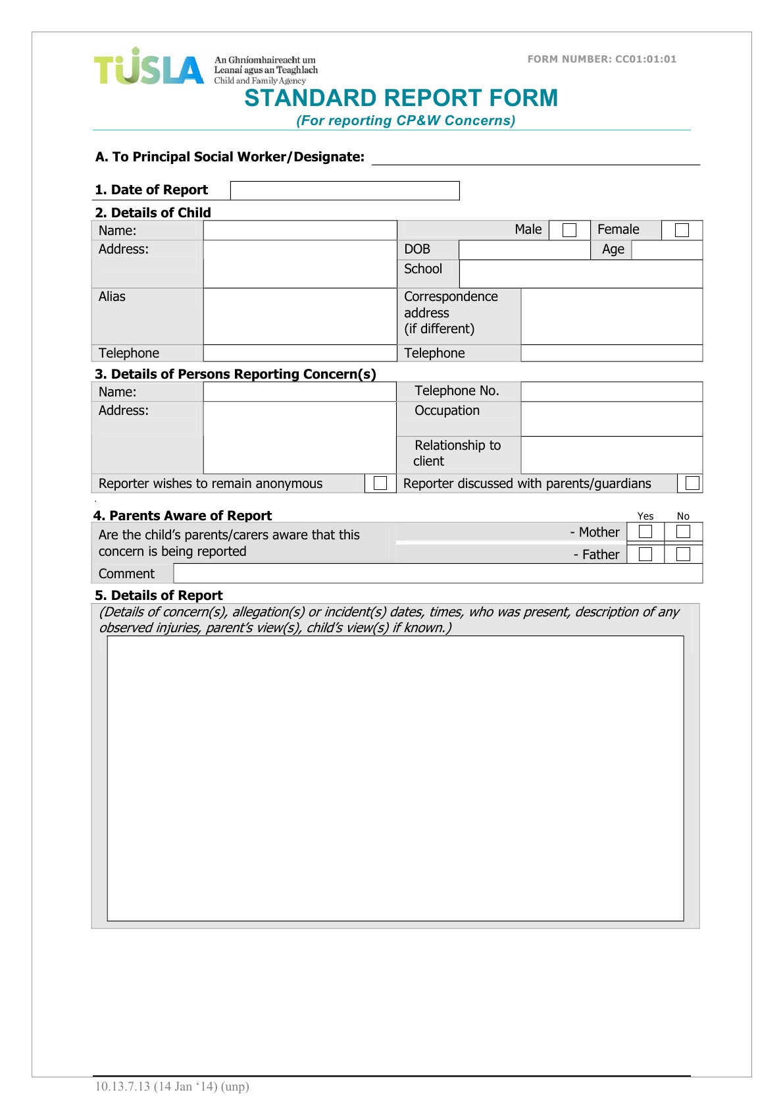
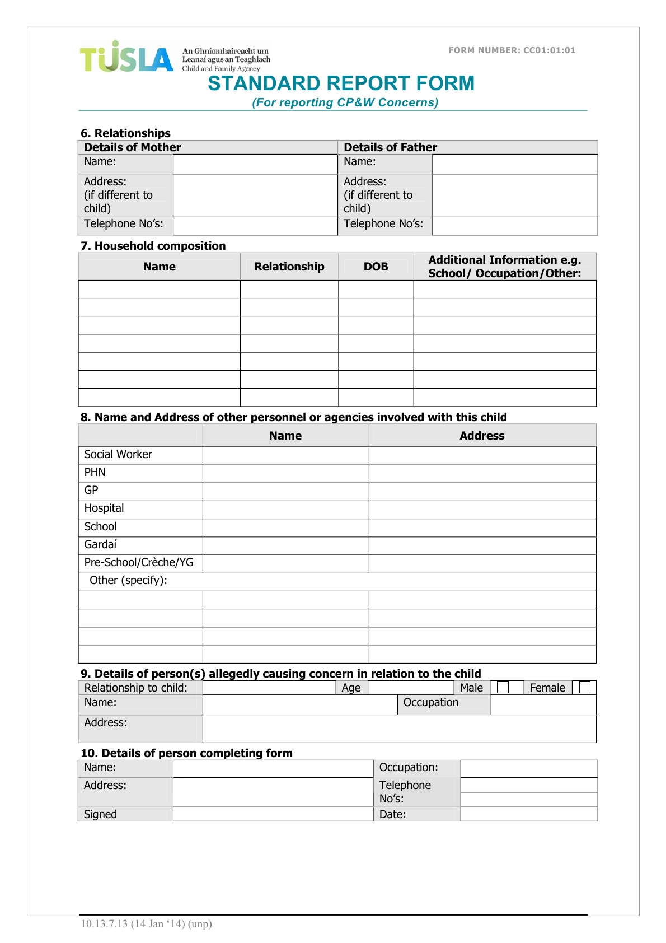
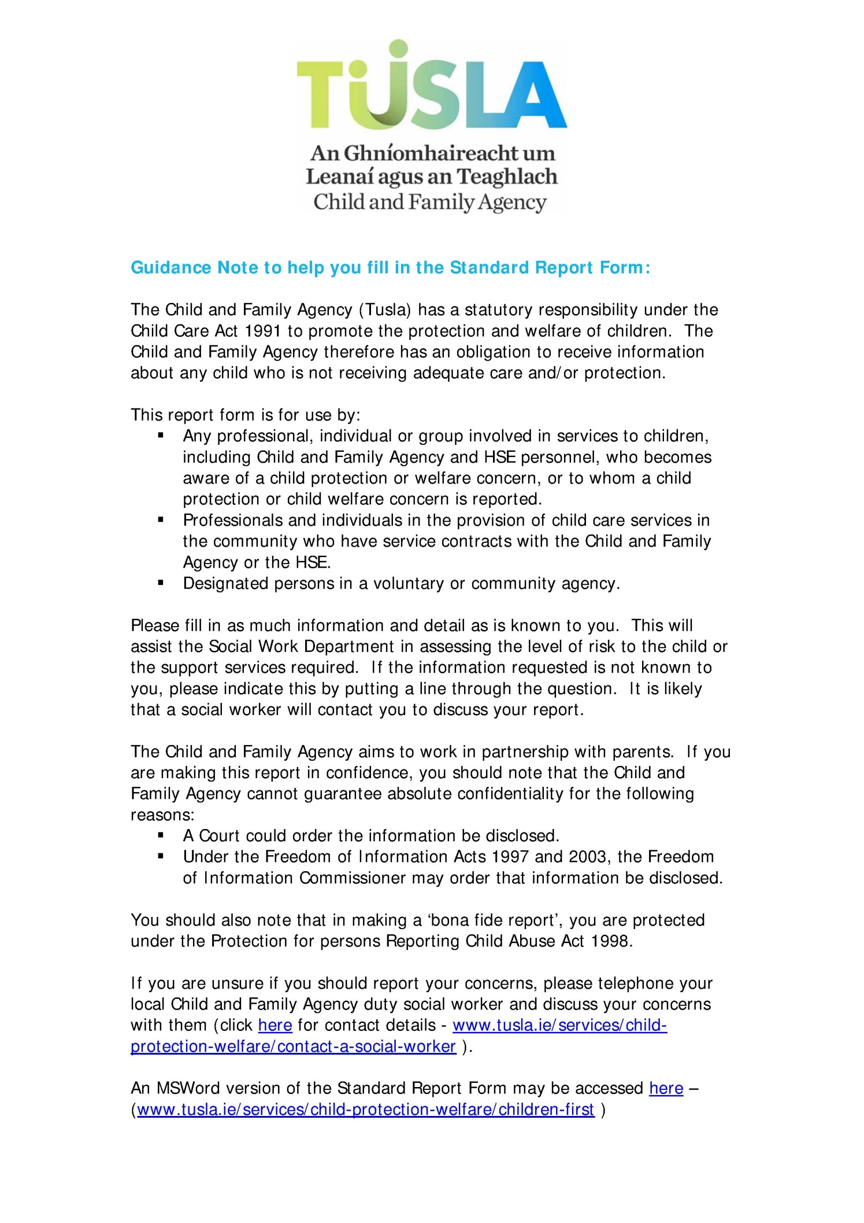

Appendix I: Consent Form Template
Galway Music Residency
[Name of Event]
Participant – Parent Consent Form
Name of Child/Young Person ____________________________________
Date of Birth: ________________________________________________
Address of Child/Young Person: __________________________________
Name of Parent/Guardian: ______________________________________

I give consent
a) for my child to participate in [event] at [location] on [date]
b) for my child to be recorded/photographed/filmed for the purposed outlined below
c) for these photographs/recordings to be retained by Galway Music Residency
d) for these images to be used by Galway Music Residency for future publicity and archiving, including print and online media, publications, brochures and other publicity materials.
Galway Music Residency agrees that these images will only be used for these purposes. The recording of these images/audio will be supervised by Galway Music Residency.
It is the responsibility of each performer to provide insurance cover for their own instrument. Galway Music Residency will not be liable for any damage caused to instruments during the event.
I also consent to my child accepting the code of conduct for the duration of the event.
Signed (Parent/Guardian): ____________________________________
Signed (Child/Young Person): __________________________________

Date: _____________________________________________________

Appendix J:

Galway Music Residency Child Safeguarding Statement

1. Name of service being provided
Galway Music Residency provides a Music Education and Music outreach service to children and young people.

2. Nature of service and principles to safeguard children from harm
Workshops with children and young adults in both groups and one-on-one settings. Workshops with children and young adults within the school setting in alignment with the Department of Education syllabi.

Our guiding principles

- Our priority to ensure the welfare and safety of every child and young person who takes part in Galway Music Residency Activity is paramount.
- Our guiding principles and procedures to safeguard children and young people reflect national policy and legislation and we will review our guiding principles and child safeguarding procedures at least every two years.
- All children and young people have an equal right to take party in Galway Music Residency Activities in a way that respects them as individuals and encourages them to reach their potential, regardless of their background.
- We are committed to upholding the rights of every child and young person who takes part in a Galway Music Residency activity, including the rights to be kept safe and protected from harm, listened to and heard.
- Our guiding principles apply to everyone in our organisation.
- Workers/volunteers must conduct themselves in a way that reflects the principles of our organisation.
To Safeguard Children:

Galway Music Residency is committed to safeguarding children in the following ways:

- A trained Designated Liaison Person and Deputy Designated Liaison Person are in place.
- All staff and relevant contracted workers have undergone Garda Vetting
- All staff and relevant contracted workers have completed have successfully completed the Children Frist E-Learning course provided by TUSLA.
- In compliance with the Governance Code for charitable organisations, Galway Music Residency is currently updating its general Health & Safety Policy. Health and Safety Risk Assessments are carried out for all events.
- In addition, a Covid 19 Health & Safety Plan is in place.
- For activities in a school setting, class teachers are asked to remain present for the duration of the activity
- For activities outside of a school setting, parents are required to remain present for the one-on-one activities. Where parents are unavailable appropriate procedures are in place. The DLP or the Deputy DLP are on call for all such activities.
- Where relevant Parent/emergency contact information is stored on GMR’s database in the event of an emergency.

3. Risk Assessment of Activities
GMR has identified the following risks | GMR Safety Procedures to address this
Risk of harm not being recognised or not being reported properly and promptly by staff / volunteers | - Staff, contracted workers, and volunteers are required to read and abide by Galway Music Residency’s Child Safeguarding Policy and Procedures;  - All staff and contracted workers working with children complete the Children First E-Learning programme
Risk of child being harmed by staff / volunteers | - Procedure for the safe recruitment and selection of workers and volunteers to work with children;  - Supervision and training provided for staff and volunteers
Risk of child being harmed by third party at activity | - Staff and volunteers should make themselves aware of any potential risks, monitor them appropriately, and act accordingly  - Guardians advised that children and young people must be signed in and out by the guardian or other named individual listed on the event registration
Risk of harm caused by staff or volunteer communicating with children in an inappropriate manner, or through an inappropriate channel | - Staff and Child Participant Codes of Behaviour in place and communicated to all involved
Bullying | - Anti-Bullying Policy in place
Inappropriate use of social media and mobile phones | - Code of behaviour in place in relation to use of information and communications technology and platforms
Inappropriate use of data/personal information | - Policies in relation to use of personal information in place
Risk of harm due to lack of clarity around roles and responsibilities in relation to Child Safeguarding | - For GMR activities where another partner organisation is involved our Child Protection Policy is shared with partners in advance of projects and GMR receives a copy of Child protection Policies from all partners. Roles, responsibilities and procedures agreed before activities.

GMR has carried out an assessment of any potential for harm to a child while participating in a GMR activity. Below is a list of the areas of risk identified and the list of procedure for managing these risks. For activities with other organisations including schools and music schools, GMR liaises with those organisations to agree respective roles and responsibilities in relation to Child Safeguarding.

4. Procedures
Our Child Safeguarding Statement has been developed in line with requirements under the Children First Act 2015, Children First: National Guidance for the Protection and Welfare of Children (2017), and Tusla’s Child Safeguarding: A Guide for Policy, Procedure and Practice. In addition to the procedures listed in our risk assessment, the following procedures support our intention to safeguard children while they are availing of our service:
- Procedure for the management of allegations of abuse or misconduct against workers/volunteers of a child availing of our service;
- Procedure for the safe recruitment and selection of workers and volunteers to work with children;
- Procedure for provision of and access to child safeguarding training and information, including the identification of the occurrence of harm;
- Procedure for the reporting of child protection or welfare concerns to Tusla;
- Procedure for maintaining a list of the persons (if any) in the relevant service who are mandated persons;
- Procedure for appointing a relevant person.
All procedures listed are available upon request.

5. Implementation
We recognise that implementation is an on-going process. Our service is committed to the implementation of this Child Safeguarding Statement and the procedures that support our intention to keep children safe from harm while availing of our service.
This Child Safeguarding Statement will be reviewed on July 2024, or as soon as practicable after there has been a material change in any matter to which the statement refers.
Signed:

Maeve Bryan, Executive Director, Galway Music Residency
NUI Galway, Riverside Terrapin, Distillery Road, Lower Newcastle, Galway

For queries, please contact Orla Henihan, Relevant Person under the Children First Act 2015
Galway Music Residency, NUI Galway, Riverside Terrapin, Distillery Road, Lower Newcastle, Galway. 091 586706 / orla@thegalwaymusicresidency.ie

The Child Care Act 1991 defines a child as a ‘person under the age of 18 years other than a person who is or has been married’ (S.2.1).
See Appendix A for definitions of abuse.
The term ‘primary carers’ refers to parents, guardians and responsible adults with primary responsibility for a child.
The term ‘Staff’ includes staff (permanent, temporary and casual), facilitators, artists, promoters, volunteers, interns etc.) working with children during the Galway Music Residency projects. Throughout this document specific responsibilities are assigned to various staff members according to suitability.
See Appendix B for definition of reasonable grounds for concern.
See Appendix H for sample form.
See Footnote 4 above for definition of ‘staff’
See Appendix G
See Appendix C
Children First National Guidance for the Protection and Welfare of Children, 2017, Department of Children and Youth Affairs, p.21 https://www.tusla.ie/uploads/content/Children_First_National_Guidance_2017.pdf
Children First National Guidance for the Protection and Welfare of Children, 2017, Department of Children and Youth Affairs, p.21 https://www.tusla.ie/uploads/content/Children_First_National_Guidance_2017.pdf
Children First National Guidance for the Protection and Welfare of Children, 2017, Department of Children and Youth Affairs, p.21 https://www.tusla.ie/uploads/content/Children_First_National_Guidance_2017.pdf
Children First National Guidance for the Protection and Welfare of Children, 2017, Department of Children and Youth Affairs, p.10 and pp.21-22 https://www.tusla.ie/uploads/content/Children_First_National_Guidance_2017.pdf

